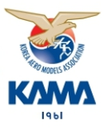

2024 FAI F3A Korean World Cup

for Aerobatic Model Aircraft

  - Bulletin 3 – 22. April, 2024

Gwangnaru model airfield

Seoul,Korea (ROK )

17th to 19th May 2024

Organised by
Precision Aerobatics Korea ( PAK )
Supported by
Korea Aero Models Association ( KAMA )

Opening Ceremony friday 17th May 2024
Closing Ceremony sunday 19th May 2024

References.
A. FAI Sporting Code Section 4 Aeromodelling CIAM General Rules 2024 Edition
https://www.fai.org/sites/default/files/sc4_vol_ciam_general_rules_24.pdf
B. FAI Sporting Code Section 4 - Aeromodelling Volume F3 Radio Control Aerobatics 2024 Edition https://www.fai.org/sites/default/files/sc4_vol_f3_aerobatics_24.pdf

Invitation.
Precision Aerobatics Korea supported by the Korea Aero models Association (KAMA) invite all FAI members to participate in the 2024 FAI F3A World Cup for Aerobatic Model Aircraft.
The event will take place from 17th until 19th May 2024. (Opening and Closing Ceremonies).

Organisers.
The event organiser is Precision Aerobatics Korea(PAK) in conjunction with
the Korea Aero models Association(KAMA).

Location.

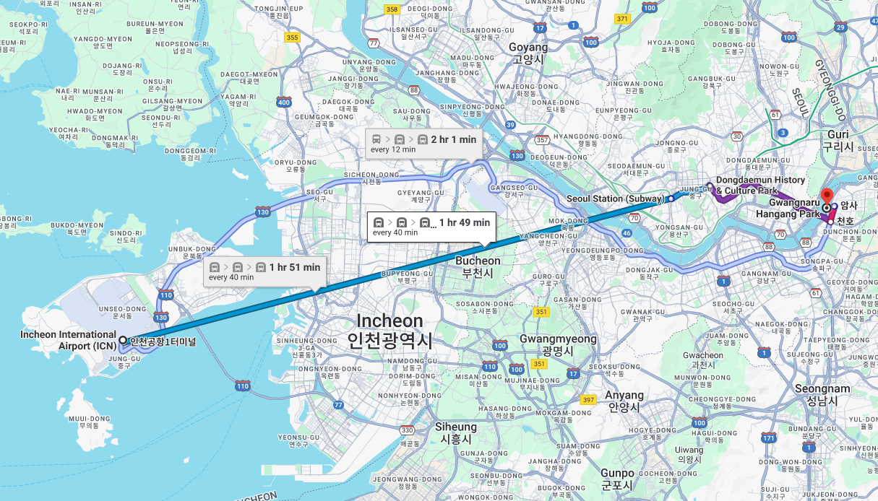
The location of the event is Seoul Korea. 37 32 50 N, 127 07 09 E

Seoul Special City
Seoul Special City)is the capital of South Koreaand a city that serves as a center of culture, humanities, politics, and economy, and serves as the central axis ofthe metropolitan areaencompassingGyeonggi-doandIncheon Metropolitan City. It is the only city in Korea designated as a special city, and as of 2023, the population is approximately 9.4 million.

Seoul is located 60 km east from Incheon international airport and event place( Gwangnaru model airfield ) is located 76 km from Incheon internation aiport.
There is an abundance of accommodations within Seoul and near Gwangnaru model airfield and the surrounding area for participants.

All participants can arrive directly from each country to Incheon international airport and there are major car rental companies service available.

The event will be held at Gwangnaru model airfield.
It is located within Gwangnaru hangang park The site is one of many model airfields in Korea in Seoul. It has one hard runway approximately 160 meter long that runs roughly south to north.

Weather.

Average temperature in Seoul in May is 27° Celsius with an average overnight temperature of 18° Celsius. The area has an average wind speed of 11 km/h during May. Seoul averages 80mm of rain in May. Event airfield is 9m above sea level while wind is typically from the West at less than 10 kph. Daylight hours for the event will be approximately 14 hours with sunrise around 5:25am and sunset around 7:25pm.

Visa Requirements

Participants and attendees should check with their local Korean Embassy or Consulate regarding visa requirements for visiting Korea.

FAI Sporting Licence.
Each competitor and team manager must possess a FAI Sporting Licence valid for the year of the event. This licence must be registered in the FAI licences database.
The holder of a FAI Sporting Licence may be required to produce an official document bearing their photograph and signature as proof of identity.

Protests.
Any protest must be presented in writing to the Event Chairman at the competition site and must be accompanied by the deposit of a fee of €50. The deposit is only returned if the protest is upheld by the FAI Jury.
It is expected that all avenues to settle matters will be extinguished before a protest is lodged. A protest is usually the last resort, if no satisfactory result has been obtained after an inquiry and then an official complaint. Please review relevant sections of References B & D.

Official Language.
The official language : English. Korean

Scoring System.
We will use the E scribe scoring system.

Printed score sheets will be available for collection at each flight line and the central administration hub.

Live scoring and live results on the Website will be possible.

Lodging FAI Jury.
Park Chanil
reserved jury
reserved jury

Judges Panel.
Naoya miyamoto ( JPN )
Chan chin Liang ( Chinese Taipei )
Yang yong (china )
Shin see kyun ( KOR )
Park chanil ( KOR )

Contest Management
Park soon cheon

Event Schedule

15. May. : practice day
16. May : practice day
17. May : 2:00pm - 3:30 pm : administration and model processing
3:30 ~ 4:00 pm : Opening Parade and ceremony
4: 00 ~ 5: 00 pm : Warm-up flight for judges ( P-25 )
18. May : 9:00 am ~~ 12:00 preliminary flights, 3 round
12:00 ~ 2:00 lunch
2:00 ~ 5:00 preliminary flights, 3 round
5: 00 ~ 6:00 pm warm up flight for judges (F-25)
19. May : 9:00 ~ 12:00 Final flights, 2 round, F-25
( half no. of pilots from preliminary )
12:00 Awards ceremony
13: 00 closing ceremony

AWARDS : best 2 of pre plus best 1 of final

Registration : https://kama.escribe.ch/events.aspx?Event=7440&lang=EN

Entry Fees
Senior : 220 $
junior : 170 $

paypal account : kama@k-ama.org , acception fee included

Entry fees will not be accepted on site upon arrival except exceptional circumstances and with prior written agreement from the organiser.

Deadlines
All entry fees must be received not later than 30th. April, 2024.
Entry fees submitted after 30th. April. 2024 will incur a 20 % penalty.

and Food

There are a number of hotels, Airbnb and holiday parks within the Gwangnaru area.
We will provide several residences on next bulletine.

The event site will have food and beverages available for purchase for the duration of the competition.

There are a multitude of places in Gwangnaru for casual dining that can be booked on a day-to-day basis. Evening meals would be expected to cost US 15.00-20.00 for a main meal.

Opening Banquet
The Opening Event Banquet on 17th May 2024 will be held near Gwangnaru air field.

from 7:00 pm ~ 9:00
Banquet fee : Senior - 25$, Junior - 20$
paypal account : kama@k-ama.org , acception fee included

Insurance
Participants will made Honorary Members of the KAMA and will be covered by third‐party liability insurance covering all model aircraft accidents involving injury to others or damage to property during training and competition.
Individual health coverage as well as travel insurance is recommended and should be purchased before arrival in Korea.
All further insurances (health, general and driver’s liability, flying out of context of the event, legal expenses etc.) are the responsibility of individual participants.
The organiser is not responsible for any kind of personal injury, loss, theft or damage to people or property during the contest including travel to/from and within Korea

Frequencies
In accordance with FAI Sporting Code Section 4 - Aeromodelling Volume F3 Radio Control Aerobatics 2024 Edition 5.1.11 only 2.4 GHz spread spectrum radio control systems are allowed.

Due to the radio frequency interference , we strongly recommand that all pilots have to use some equipment
for receiver redundancy with dual receivers.

We should check the redundancy mode for fail-safe
during model processing.

Model Aircraft Specifications Certificates
In accordance with Reference B, specifically Paras C.11.1 and C.12, model aircraft, shall carry:
- The national identification mark followed by the FAI Unique ID number. The letters and numbers must be at least 25 mm high and appear at least once on each model.
- A model identification code (letters and/or numbers). This code must be different for each nominated model aircraft of the competitor. The model identification code is to appear on each main part of the model (wing(s), tail, front and rear fuselage if detachable) so that the individual parts of a competitor's different models may be separately identified. The letters and/or numbers must be at least 10 mm high and clearly visible. The identification code of the nominated models must be recorded on the Model Aircraft Specification Certificate.
- For the event, each NAC shall process every model and shall issue for each model aircraft a Model Aircraft Specification Certificate, provided by the FAI. A sticker, also provided by the FAI or marking to the pattern of this sticker, shall appear on each model.
- Each competitor must present a correctly completed FAI Specification Certificate for each model aircraft entered in accordance with the Sporting Code. Specification certificates must be signed and stamped by the National Airsport Control Organisation.
- Model aircraft not properly processed by their NAC, with FAI certificates and stickers, must be processed by the organiser at a cost of 8 Euro for each model.

Maximum total weight, Electric powered models with batteries,Internal Combustion powered models with completely filled fuel tank...................5500g

Practice Sites
There will be possible to practice at Gwangnaru air-field
from 9:00 AM till 5:00 pm on 15,16, May and before noon on 17,May .
Planned practice sites for the event are: 106 m in length, hard covered runaway and
Planning of practice would be pre-arranged with us.
Feel free to contact with Contest manager Miss Park soon cheon.
( 82-10-3712-4742 , 82-10-8971-0896 )

National Drone License
We prepare the temporary national drone license.
It is Korean Government requirement that you must have approval of a property owner to fly.
It should be required for this temporary license with your Birthday.
It should be filled in registration.
Name | Nationality | Birthday/Passport No. | plane name | manufacturer of plane/product No. | Total weight | Width/ length | Photos of plane( front, side- 1 each ) , be attatched to e-mail | Photo of pilot  ( same with Passport ),be attatched to e-mail

There are also needed to attatched piolt’s photo and plane’s photos ( viewed from front and from side ) via e-mail , beaton@naver.com

Attachment
- Site Layout

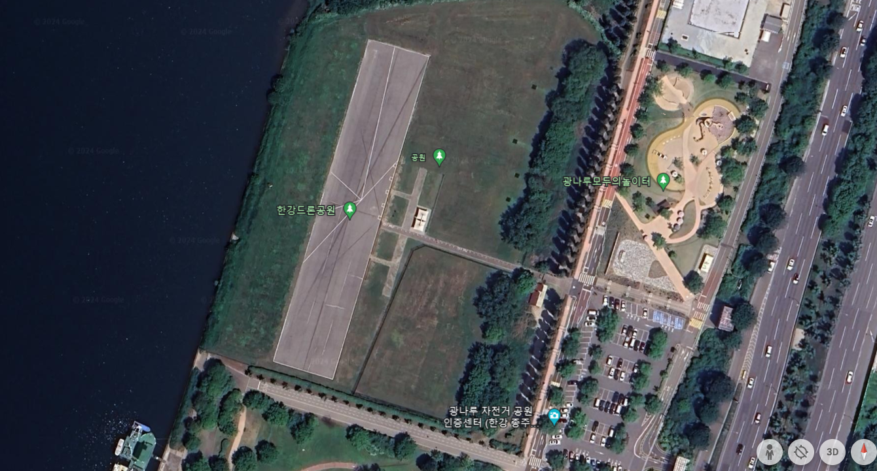

2. Accommodations
a. http://seoulyh.go.kr/.en/

b. https://www.airbnb.com/s/seoul/homes

3. rental car
https://www.rentalcars.com/

